



**DEPARTMENT OF COMPUTER SCIENCE**

**AND APPLICATIONS**

**IBM PROJECT REPORT**

**TOURISM MANAGEMENT**

*Submitted by*

**BACHELOR OF SCIENCE IN COMPUTER**

**SCIENCE WITH ARTIFICIAL INTELLIGENCE**

*Under the guidance of*

*Aiswarya Vijayan - Corporate Trainer*

**2023 - 2024**

**DECLARATION**

We ,**Manikandan.L, Bharathkumar.E. A** hereby declare that this project report on **“**Analysing hotel management system data using COGNOS tool” submitted to University of Madras in partial fulfilment of the requirement for the award of the Degree Bachelor of computer science with Artificial Intelligence under the guidance of **DR.G.MONIKA M.Sc., PhD., HEAD OF DEPARTMENT** and **SUBHA SRI. S** has not been submitted earlier to any other university or institute for the award of any degree.

**MANIKANDAN.L**

**BHARATHKUMAR.E**

**Place:**

**Date:**

**BONAFIDE CERTIFICATE**

This is to certify that the project titled “Analysing hotel management system data using COGNOS tool”is the bonafide work done by , **Manikandan.L and Bharathkumar.E. A**hereby and first year student of Jeppiaar College of Arts and Science , Padur, Chennai in partial fulfilment of the requirment for the award of the Degree of Bachelor of computer Science with Artificial Intelligence 2023-2024.

**PROJECT GUIDE: SUBHA SRI. S**

**HEAD OF THE DEPARTMENT:**

**Date:**

|  |  |  |
| --- | --- | --- |
| **S. No** | **INDEX** | **Page No** |
| 1. | INTRODUCTION |  |
| 2. | ABSTRACT |  |
| 3. | REPORTS  1.TOURISM DATABASE AS LIST  2.GROWTH OF TOURIST PEOPLE  3.NO.OF.PERCENTAGE OF TOURIST PLACES |  |
| 4. | FINNAL DASH BOARD |  |
| 5. | CONCLUTION |  |

**INTRODUCTION**

The travel industry is witnessing a fascinating metamorphosis. Tourists are no longer content with generic brochures and pre-packaged tours. Today, they demand **individualized experiences**, crafted to their unique preferences and travel styles. This transformation is fueled by a powerful force **data** IBM Cognos Analytics emerges as the magic wand for tourism businesses to weave this data-driven spell. It acts as a central hub, collecting vast amounts of information from bookings, social media, and travel apps. This rich data stream, when visualized effectively, becomes the key to unlocking **hyper-personalized experiences**.

**ABSTRACT**

The travel industry is on the cusp of a data-driven revolution. Tourists are no longer satisfied with one-size-fits-all experiences. They crave **individualized journeys** that cater to their unique desires. This abstract explores how **IBM Cognos Analytics**, with its powerful visualization tools like **lists, crosstabs**, and various **visualizations**, empowers tourism businesses to leverage data and design transformative experiences.

**REPORTS**

**1.TOURISM DATABASE AS LIST**

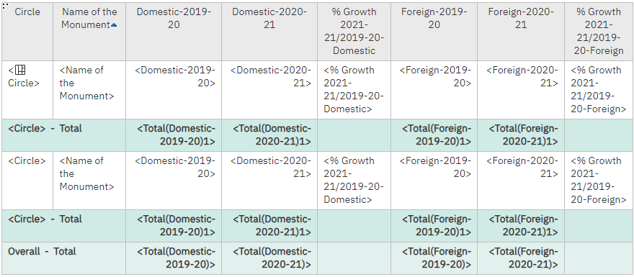

**OUTPUT**

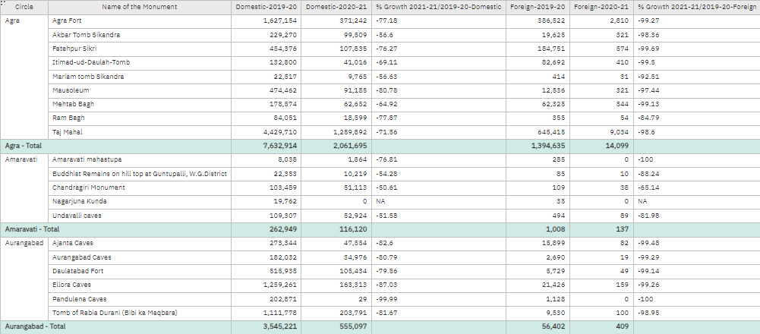

**2.GROWTH OF TOURIST PEOPLE**

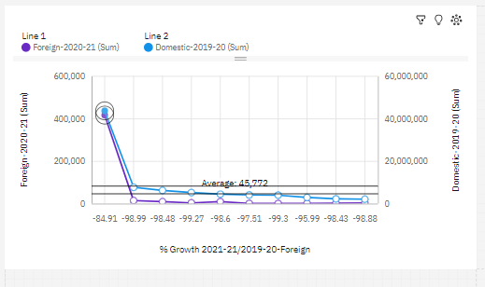

**3.NO.OF.PERCENTAGE OF TOURIST PLACES**

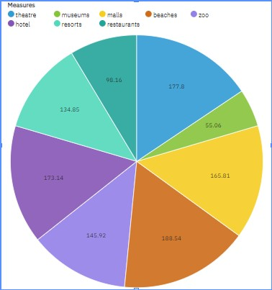

**4.FINAL DASHBOARD**

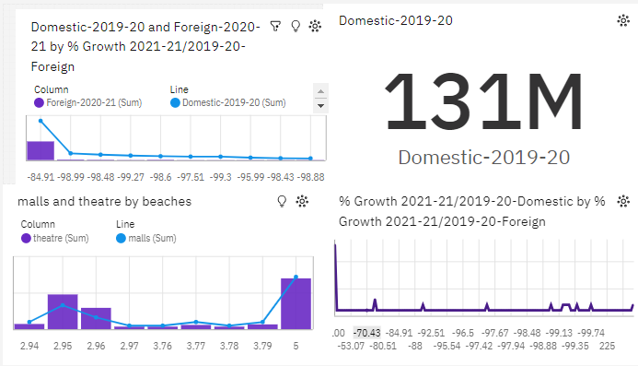

**CONCLUSION**

In conclusion, leveraging IBM Cognos Analytics for transforming tourist experiences through data-driven approaches offers a plethora of benefits and opportunities. By harnessing the power of features like lists, crosstabs, visualizations, and tables, tourism stakeholders can unlock valuable insights, enhance decision-making, and ultimately elevate the overall tourist experience.

**REFERENCE**

**1.**[**https://us3.ca.analytics.ibm.com/bi/?perspective=dashboard&pathRef=.my_folders%2FNew%2Bdashboard%2B17&action=view&mode=dashboard&subView=model0000018f0937de26_00000002**](https://us3.ca.analytics.ibm.com/bi/?perspective=dashboard&pathRef=.my_folders%2FNew%2Bdashboard%2B17&action=view&mode=dashboard&subView=model0000018f0937de26_00000002)

**2.**